Dear Resident/Business Owner

Bures St Mary Parish Council , is exploring opportunities to designate certain rural lanes in the village as “Quiet Lanes” as part of a county-wide project.

According to responses to the Joint Parish survey, residents considered Road Safety to be one of the top priorities for the village in the future. Quiet Lanes are a nationally recognised designation for narrow, rural roads which are shared by walkers, horse riders, cyclists and other road users. They encourage drivers to ‘Expect and Respect’ more vulnerable road users and so allow non-motorised users to enjoy rural lanes in greater safety.

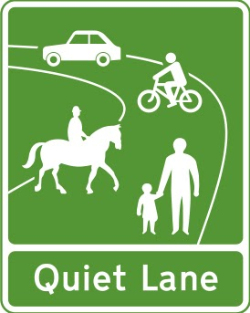
These types of lanes do not impose traffic restrictions and are not enforced. Advisory signs (like the one opposite) are placed at either end of Quiet Lanes to remind motorised users that the road is a shared space.
We feel that this would be of real benefit to the village and to those who visit. The lanes being considered are already used by walkers, cyclists and horse riders and some link with existing footpaths and bridleways in the area.
We have provisionally identified, in conjunction with Suffolk County Council (Highways), Arger Fen to Gazley Gate (in partnership with Assington PC), St Edmunds Lane and Hollow Lane. as being suitable for designation – see lanes marked on the map.

With the current limited nature of parish council public meetings this letter seeks to inform you as the first stage of a full public consultation process.

If you wish to make any comments about these proposals at this initial stage, we would welcome these in writing either by email to the Parish Council Clerk buresparishcouncils@gmail.com or by post to Mrs Jenny Wright, 38, The Paddocks, Bures, Essex CO8 5DF.

This project is dependent on a funding bid by Quiet Lanes Suffolk Board to the Suffolk County Council 2020 Fund. If the bid is successful, a formal public consultation process can start. There will be a public meeting (held virtually) at a future date to discuss these proposals.

For more information about this project see the Quiet Lanes Suffolk website - www.quietlanessuffolk.co.uk
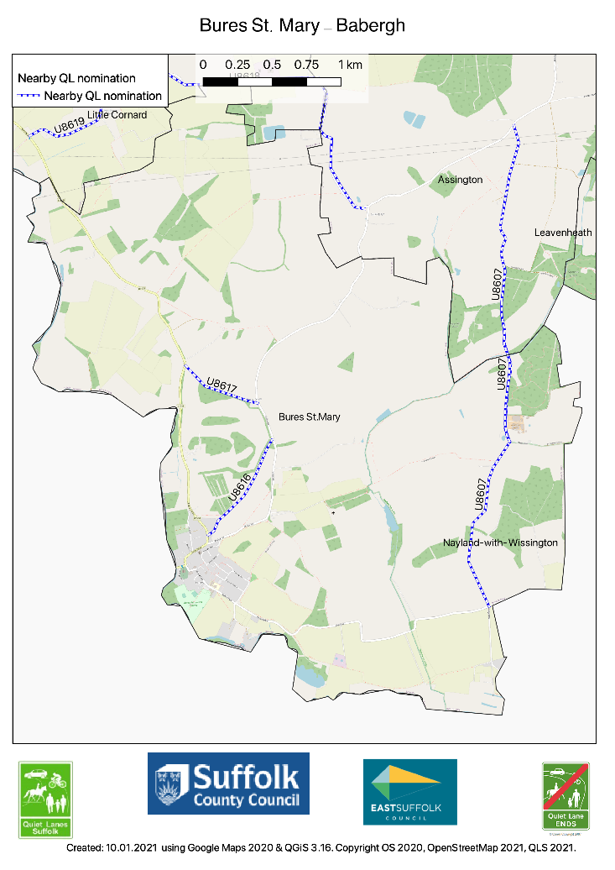

Jan Aries Vice-Chair – on behalf of the Bures St Mary Parish Council

February 2021

