Footpath  Number | Location and Description of Reported Problem/Resolved Problem | Ref. No.
FP5 | From Ferrier’s Farm to Horne’s Green ( a field margin path, leading to a cross-field path through some scrub and into a wood, then onto a well-kept grassed lane to the road)  A waymarker remains tied up to a makeshift post with twine to keep it in place. Another is concealed by ivy and completely rotten at its base.  These two waymarkers are still awaiting repair. The Clerk has suggested that the Parish Council might consider ordering some replacement posts so that one of our contractors could carry out these minor works as they arise.  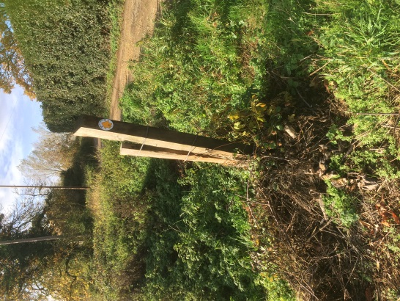  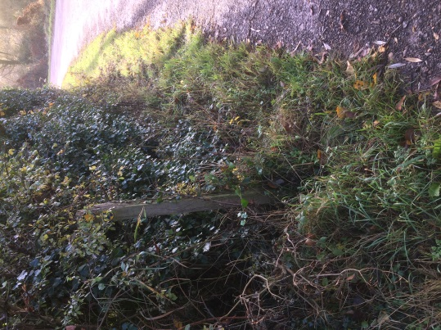  Generally across the Parish of Bures Hamlet, most of our footpaths remain passable and fairly firm with evidence of regular use.
Footpath  Number | Location and Description of Reported Problem/Resolved Problem | Ref. No.
FP 23 | This path runs from Hobb’s Well to the Mount Bures Road. For a short distance of some 15m.with a stile either end, this section is overgrown and unused. Walkers use an adjacent enclosed track via a livestock gate at either end. This has been in practice for several years now. In early Spring, it would be advisable to clear the official footpath and reinstate its use. Both the disused path and the track then open onto a path leading along the edge of cultivated field to the road.
FP8 and Balls Road | The Balls Road junction onto the Colne Road by Bakers Hall Farm forms part of several important circular walks. It involves, however, a very hazardous section of road walking to link with FP8 which then continues down to Ferrier’s Cottage.  This is an ‘unrestricted speed’ road with the brow of a hill and a sweeping bend.  There are 18 hazard bollards flanking Baker Hall Farm’s garden. The owners keep the hedge cut back so walkers can safely use the verge between the hedge and the bollards for part of the road walk.  There is a high, uneven bank on the opposite of the road which is currently. difficult to negotiate to avoid oncoming traffic. However, this could be a project to extend safe road walking right up to FP 8 by levelling the bank and creating an even verge if Highways would consider it safe to do so.
FP30 | From Colne Road next to Parsonage Grove crossing the railway to The Paddocks.  The Parish Council is awaiting the outcome of the Network Rail Public Inquiry for Level Crossings Reduction in Essex with regard to the fate of the above ‘passive crossing’. The Parish Council were invited to attend the concluding session but it was decided nothing further could be added to our case to keep the crossing open. Councillors did not attend.  The Clerk has tried to establish the ownership of the triangular grass verge at the Water Lane  Junction as Network Rail intended to use this as part of their alternative footway. Essex County Council say that the verge does not come under Highway Rights but are unclear as to the ownership of the land. | (Crossing E54)
Jan Aries 10th January 2019

