Footpath  Number | Location and Description of Reported Problem/Resolved Problem | Ref. No.
FP5 | From Ferrier’s Farm to Horne’s Green ( a field margin path, leading to a cross-field path through some scrub and into a wood, then onto a well-kept grassed lane to the road)  A waymarker remains tied up to a makeshift post with twine to keep it in place. Another is concealed by ivy and completely rotten at its base.  These two waymarkers are still awaiting repair.  The boggy section of FP5 and the lack of any signage once across the field have been reported AGAIN. These reports are removed from the database without further action after a period of time.  The Clerk has approached the Essex PROW Officer about supplying the Parish Council with some finger posts so that we can carry out our own replacement and repairs of finger posts and waymarkers. Before we can replace damaged posts we are still required to notify the Highways Dept. so that they can conduct a risk assessment to establish it is safe and permissible to proceed. I have sent the PROW Officer maps of the location of these posts so that the necessary checks can be carried out. We await authorisation to replace the posts using our parish contractors.  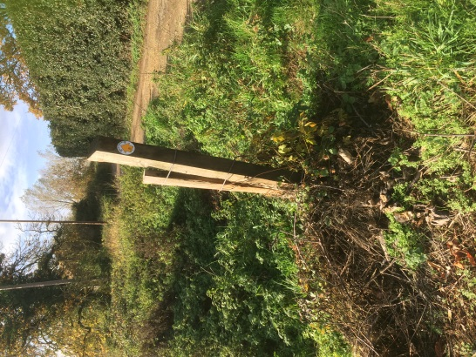  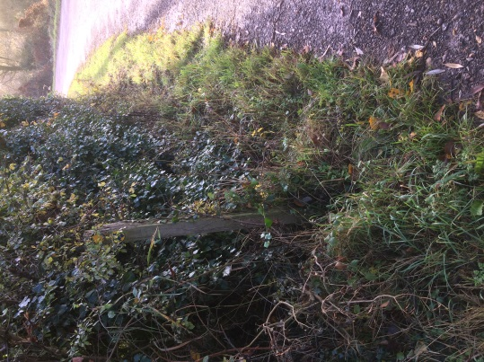  Generally across the Parish of Bures Hamlet, most of our footpaths remain passable and fairly firm with evidence of regular use. | Ref: 2607732  Reported; 28/02/19
Footpath  Number | Location and Description of Reported Problem/Resolved Problem | Ref. No.
Byway 25 | Essex Highways carried out extensive repairs on this byway last year at the Balls Road end. This is a byway and as such is regularly used by horse riders, cyclists and others. There is now deep rutting and standing water at the Broad Oaks end of the track leading onto Colne Road.  An inspector will carry out an initial inspection which might include a site visit. This process can take up to 28days from the date of reporting the issue. | Ref: 2606371  Reported 18/02/19
FP30 | From Colne Road next to Parsonage Grove crossing the railway to The Paddocks.  The Parish Council is still awaiting the outcome of the Network Rail Public Inquiry for Level Crossings Reduction in Essex with regard to the fate of the above ‘passive crossing’.  We are now in a position to start drawing up a plan as a joint venture for a Bures Walks leaflet following the successful bid for funding from Braintree District Council. The Clerk applied for a £500 Councillors’ Community Grant which has been duly awarded and we now have six months in which to spend it! BSM are also applying for funding from the SCC Locality Budget. | (Crossing E54)
Jan Aries 1st March 2019

