Footpath  Number | Location and Description of Reported Problem/Resolved Problem | Ref. No.
FP2  FP3 | Bures/Sudbury Road lay-by to Dorking Tye.  Having left the lay-by and walked passed the conifers on the right, there is then a cross field section to this footpath which passes through a maize border for pheasant cover before opening onto an open cultivated field. The field now has crops coming through but there is no clearly marked footpath across the ploughed field (such a tractor tracks). Cross-field footpaths should be reinstated two weeks after ploughing and this obviously has not been done.  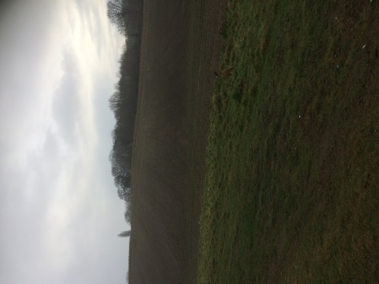  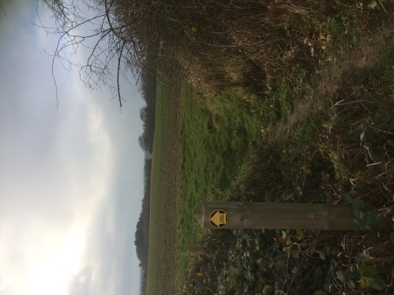  FP2 FP3  Bures/Sudbury Road lay-by to Assington Road via Corn Hall  This is another cross-field footpath on the same estate which again has not been fully reinstated after ploughing. It can be heavy-going for walkers when trying to traverse the loose ploughed soil. There are some random tractor tracks but these are not true to the footpath. I will check for a reinstatement in the spring but not report it at present. | Ref: 4653744  Reported 11.01.19
Footpath  Number | Location and Description of Reported Problem/Resolved Problem | Ref. No
FP11 | From Moat Farm to Gazley Gate. There is a wooden footbridge which crosses the Assington Brook at a junction with another footpath leading northwards to Tiger Hill Woods. The bridge is getting very rickety with the handrails being secured with twine and strapping. The bridge no longer feels stable its entire length when being crossed and some of the boards are loose.  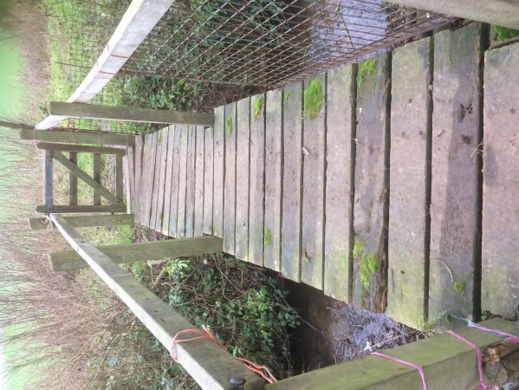  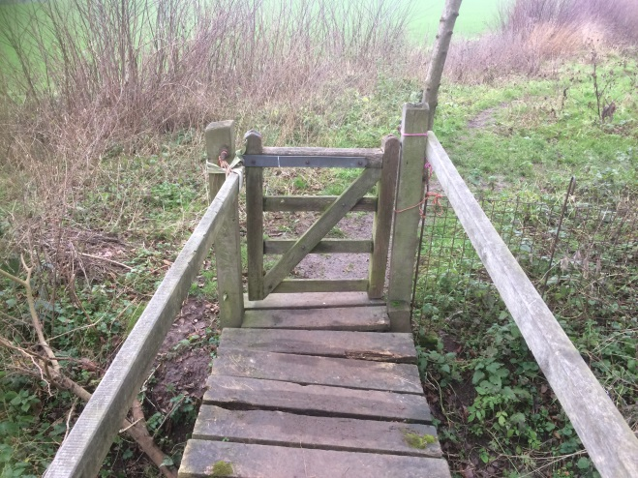 | Ref: 4648929  Reported 06.01.19
FP14,17,18 | From the foot of Clicketts Hill to Smallbridge Hall. This footpath runs by the Sewage Works and then passes through a kissing gate onto the flood meadows. The two waymarker posts at this point have rotted at their bases and need replacing.  The Clerk has suggested that the Parish Councils consider buying in a few fingerposts and waymarkers so that our contractors can undertake repairs promptly rather than waiting for County. | Ref: 4651645  Reported 09/01/19
Most of the footpaths in the Parish have been checked and are fairly firm underfoot as this has been a relatively dry winter so far.
Jan Aries
11th January 2019

