Footpath  Number | Location and Description of Reported Problem/Resolved Problem | Ref. No.
FP11 | From Moat Farm to Gazley Gate. There is a wooden footbridge which crosses the Assington Brook at a junction with another footpath leading northwards to Tiger Hill Woods. The bridge is getting very rickety with the handrails being secured with twine and strapping. The bridge no longer feels stable its entire length when being crossed and some of the boards are loose.  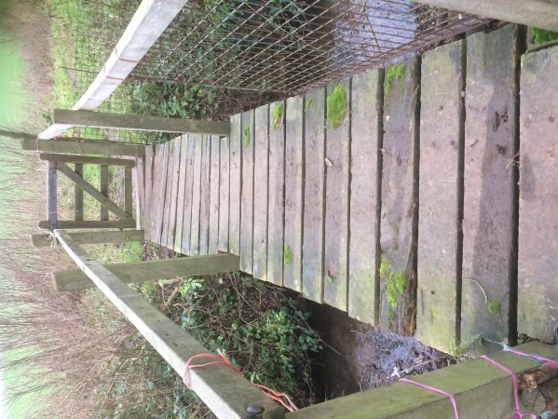  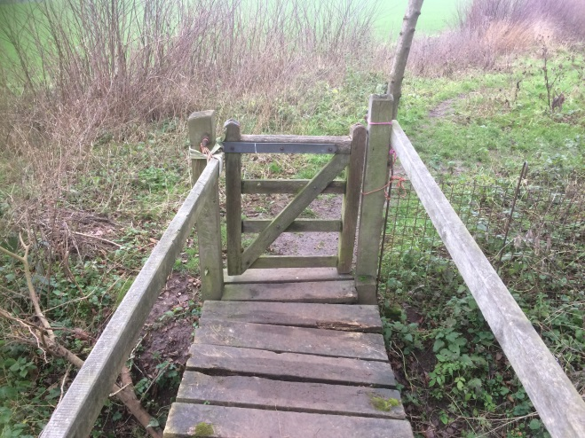  SCC has inspected the bridge and has issued this response: The route has been inspected and we don’t believe the bridge is in danger of immediate collapse. We will put the works on our Capital List for replacement as a priority but cannot advise when the works will be completed. | Report No: 4648929  Reported 06/01/19  (also in January 2019 PROW report)
Footpath  Number | Location and Description of Reported Problem/Resolved Problem | Ref. No
FP 13 | The finger post positioned in the hedge by the Old Police House was badly damaged following hedge cutting. It was duly reported. I received a telephone call to confirm that the report was being processed and the finger post was repaired within days! | Ref: 4659524
FP14,17,18 | From the foot of Clicketts Hill to Smallbridge Hall. This footpath runs by the Sewage Works and then passes through a kissing gate onto the flood meadows. The two waymarker posts at this point have rotted at their bases and need replacing. Awaiting repair. | Ref: 4651645  Reported 09/01/19
Byway 15 | The finger post at the west end of Dead Lane by Buckfield House has rotted away at the base. The report has been acknowledged via email and has been added to the SCC works list. | Ref: 4682802  Reported 18/02/19
FP16 | The finger post at the entrance from St Edmunds Lane has rotted away at the base. Awaiting repair. | Ref: 4682802  Reported 18/02/19
All the footpaths in the Parish have been checked and are fairly firm underfoot as this has been a relatively dry winter so far.
As a point of interest, Suffolk has over 3,500 miles of public rights of way and over 12,000 acres of open space!
We are now in a position to start drawing up a plan as a joint venture for a Bures Walks leaflet following the successful bid for funding from Braintree District Council. The Clerk applied for a £500 Councillors’ Community Grant which has been duly awarded and we now have six months in which to spend it! BSM are also applying for funding from the SCC Locality Budget.

Jan Aries
1st March 2019

